**Dhyandev -Project**

**GITHUB LINK = https://github.com/REBOXDUDU/SQL-ENTRI-DHYANDEV**

**1. Retrieve the book title, category, and rental price of all available books.**

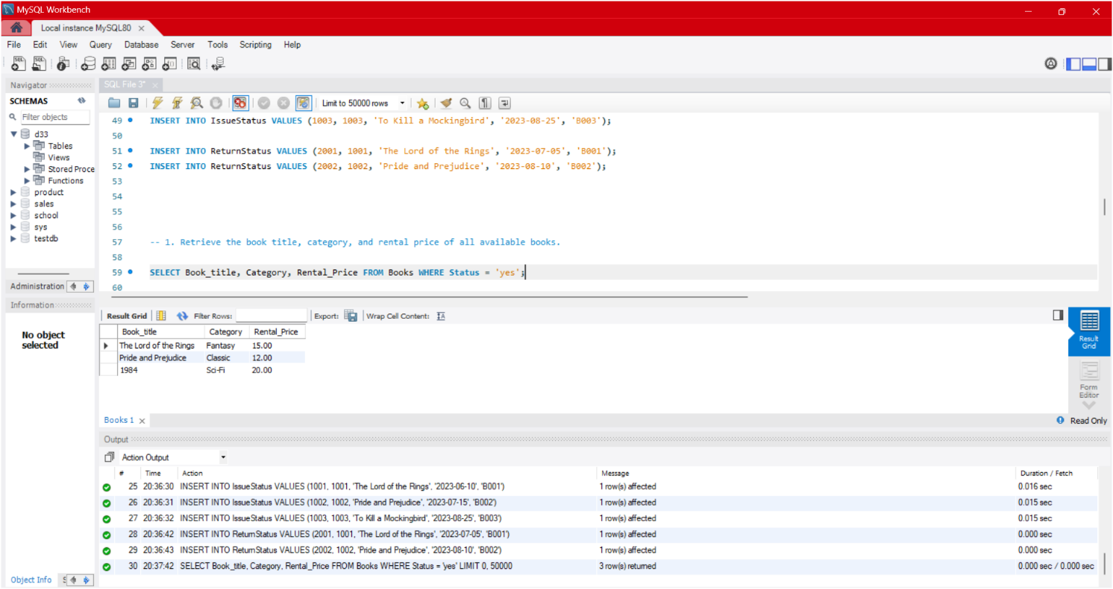

**2. List the employee names and their respective salaries in descending order of salary.**

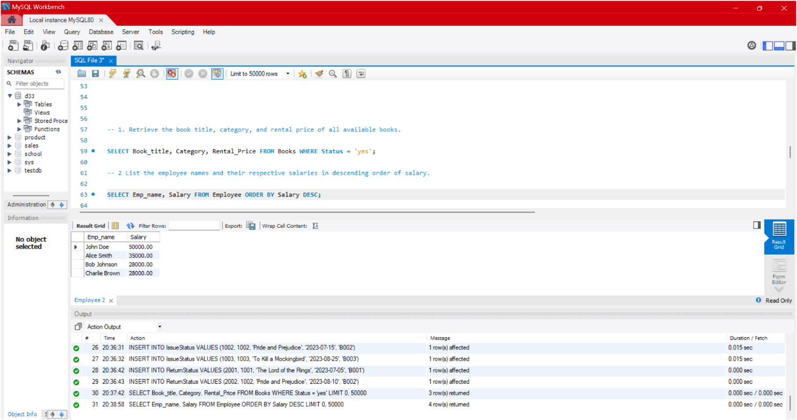

**3. Retrieve the book titles and the corresponding customers who have issued those books.**

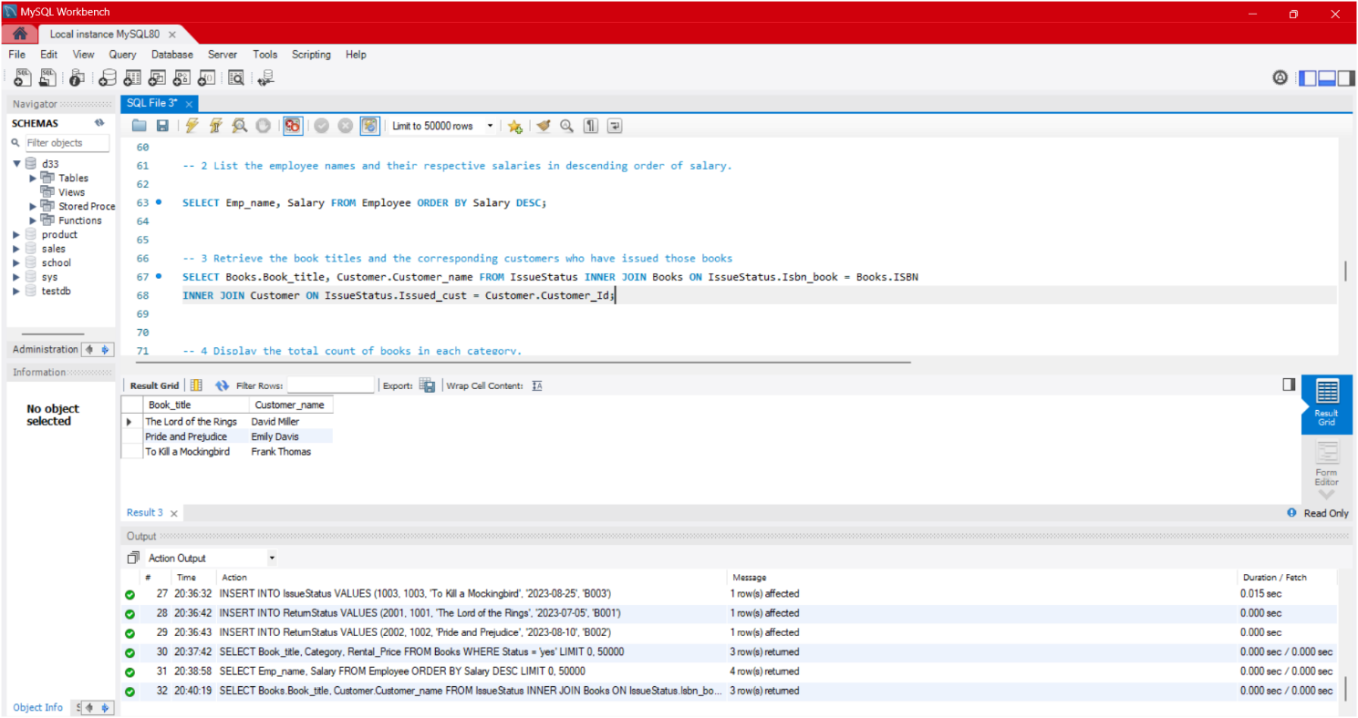

**4. Display the total count of books in each category.**

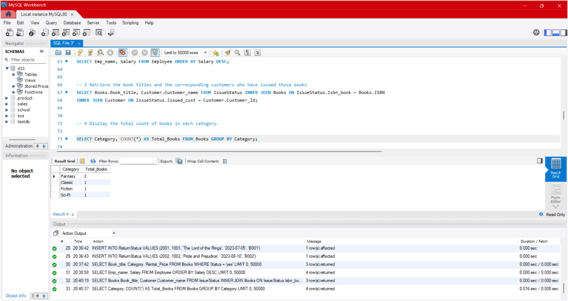

**5. Retrieve the employee names and their positions for the employees whose salaries are above Rs.50,000.**

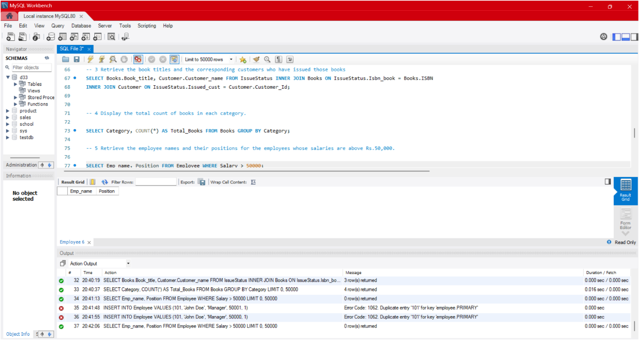

**6. List the customer names who registered before 2022-01-01 and have not issued any books yet.**

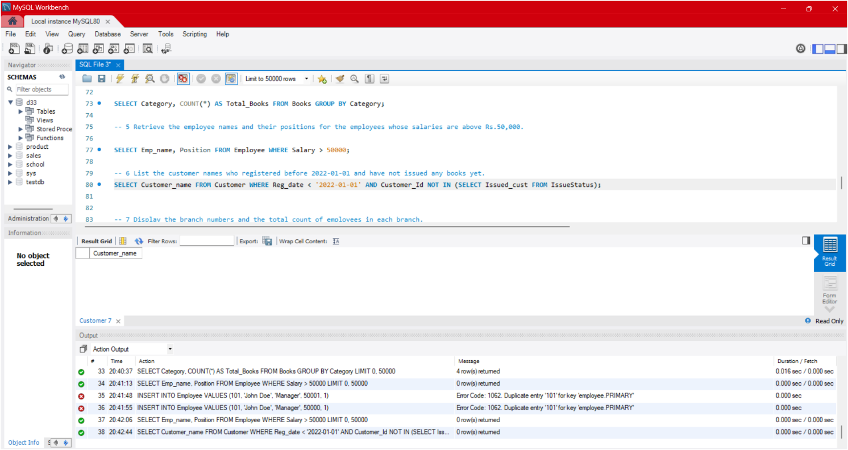

**7. Display the branch numbers and the total count of employees in each branch.**

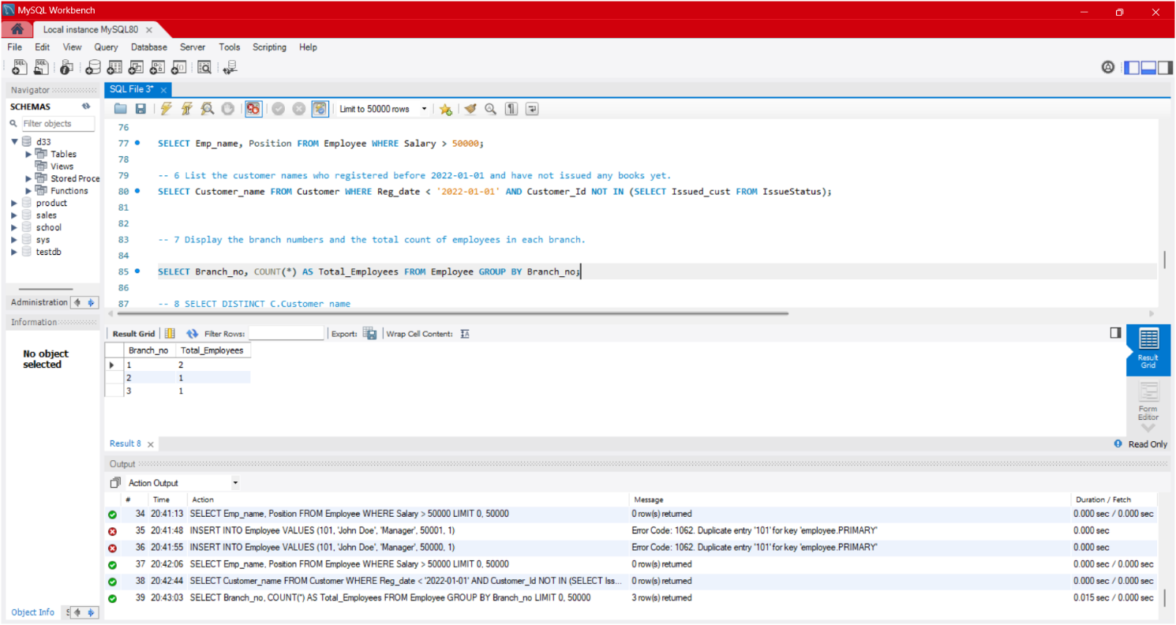

**8. Display the names of customers who have issued books in the month of June 2023.**

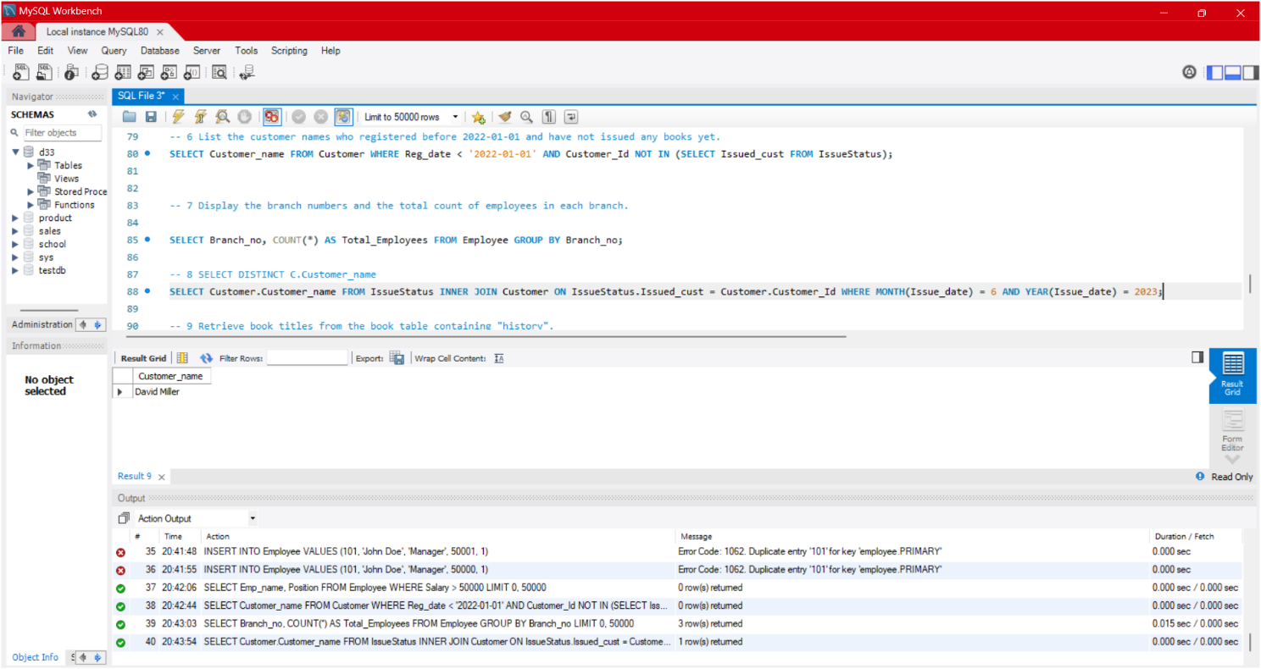

**9. Retrieve book title from book table containing history. (Changed history to Mystery/Thriller)**

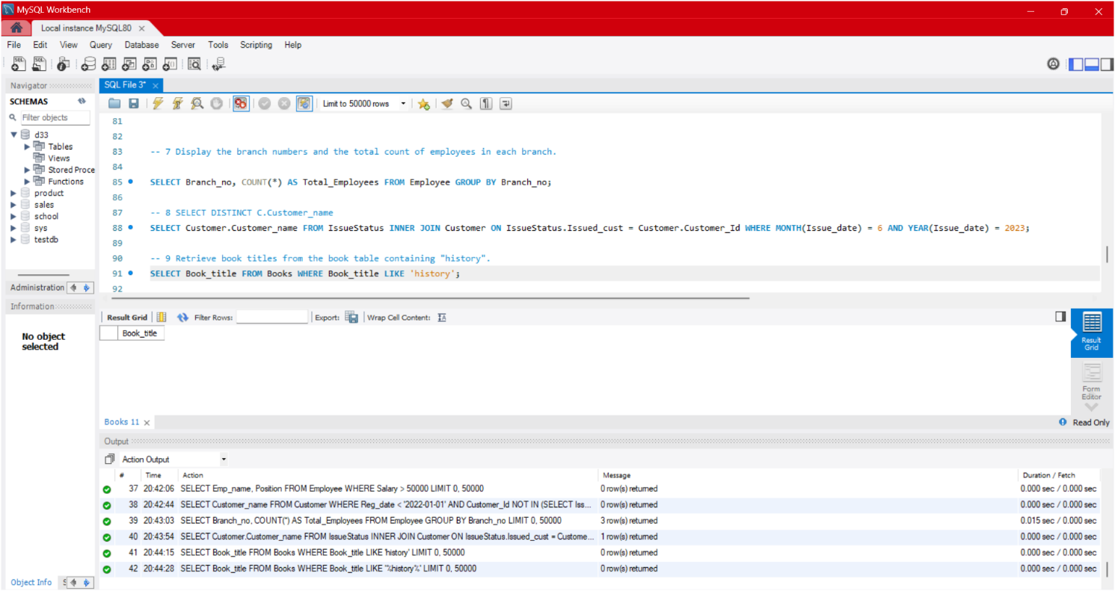

**10.Retrieve the branch numbers along with the count of employees for branches having more than 5 employees**

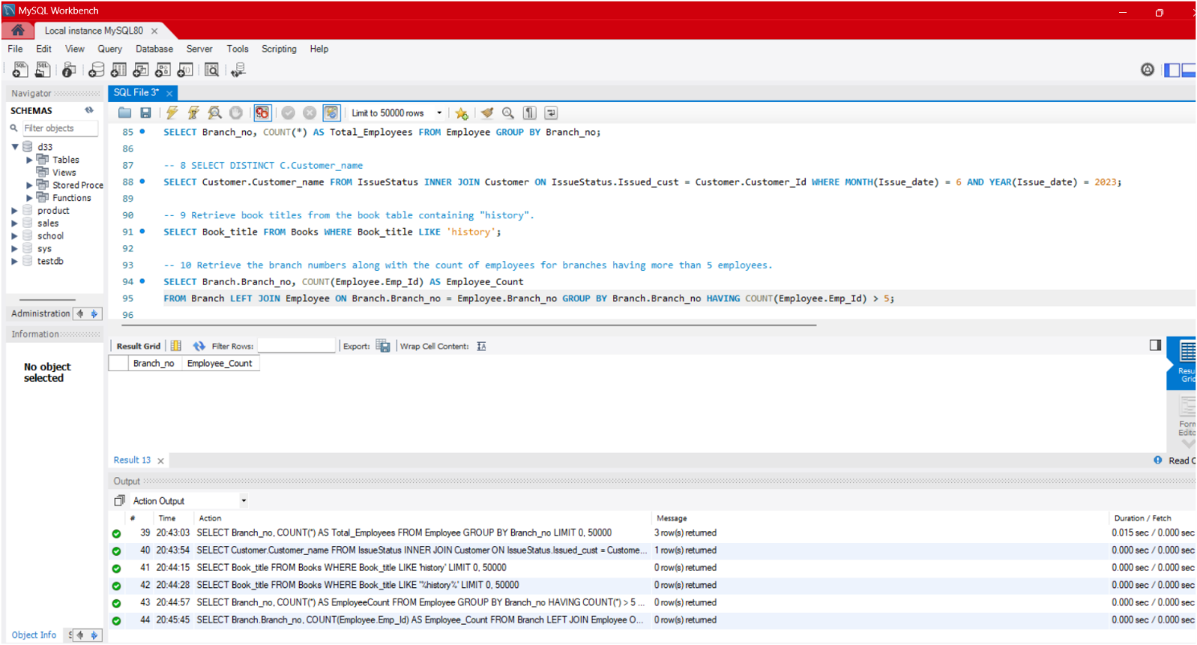

**11. Retrieve the names of employees who manage branches and their respective branch addresses.**

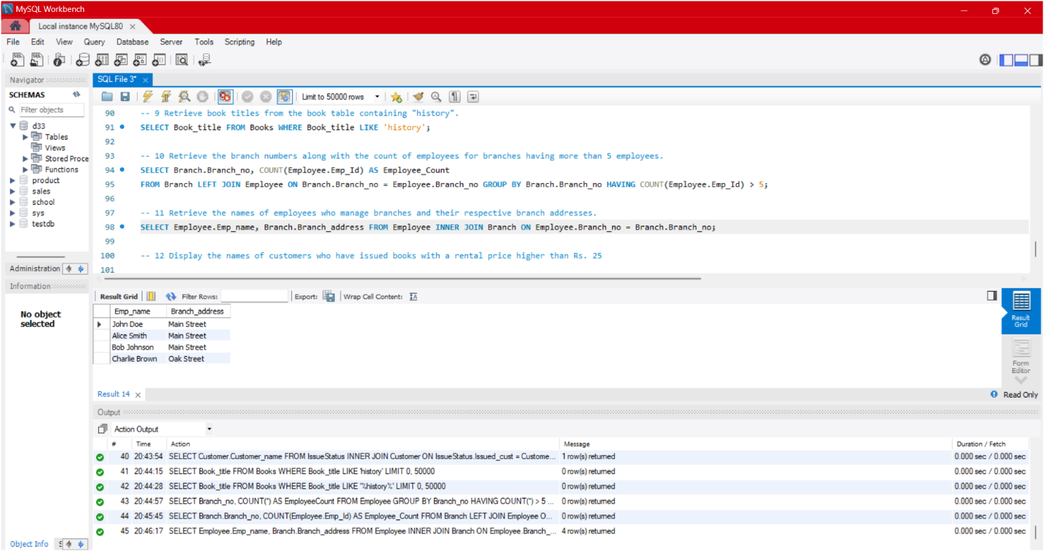

**12. Display the names of customers who have issued books with a rental price higher than Rs. 25.**

